7 in 100 veterans struggle with PTSD. A new bill would allow SC doctors to treat them with medical marijuana.
A South Carolina bill could legalize medical marijuana for veterans with PTSD from their service.
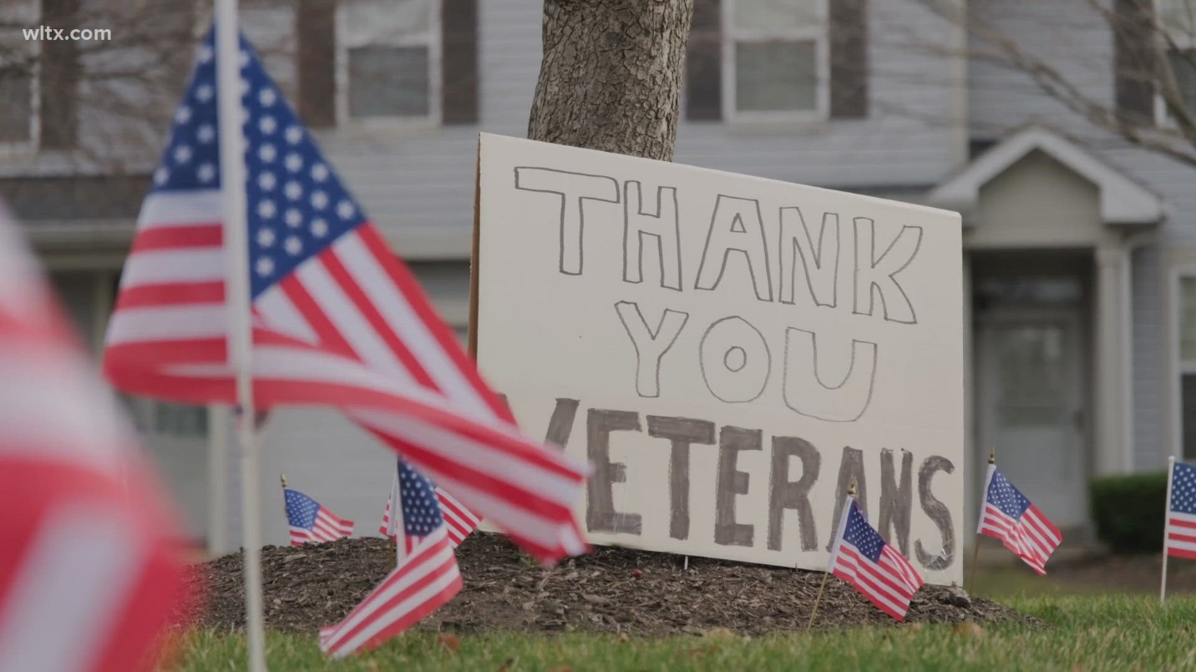

Next up in 5
Chiefs' strategy: Rest Mahomes or risk further injury?

Why a poor finish to the season could greatly benefit the Carolina Panthers in the offseason

Author: Josie Frost
Published: 8:05 PM EST December 15, 2024
Updated: 5:38 AM EST December 16, 2024

COLUMBIA, S.C. — Veterans with Post-Traumatic Stress Disorder (PTSD) in South Carolina may soon have access to medical marijuana after a bill pre-filed in the South Carolina House seeks to legalize it.
Advocates say it could offer relief for those managing the lasting impacts of trauma. The proposed legislation would allow veterans with a combat-related PTSD diagnosis to possess one ounce of marijuana or 10 grams of hashish for veterans with service-connected PTSD.

PTSD affects 7% of all veterans, according to the National Center for PTSD
Kevin Purdy, an Army veteran of over 20 years, said PTSD affects each person differently.
"I was seeing young kids that had missing limbs, legs and arms from picking up toys, and they were covering land mines and stuff like that. So to me, that was always a bigger part of what bothered me," said Purdy. "When I first came in it was always, you know, be a man. Be a man... you got to be tough, and you can't let this stuff bother you. But this day and age, it's like, hey, if you've got a problem, talk to somebody."
He says seeking treatment is crucial, and he'd like to see options expanded.
“Medical marijuana has been brought up multiple times...and to me personally, I think that does have benefits. I think it would definitely help,” Purdy said.

Bill would legalize marijuana for treatment with a few conditions
Representative Todd Rutherford, who pre-filed the bill, said if the state won't legalize medical marijuana for everyone with a prescription, they should at least pass the bill to make it available for PTSD-affected veterans.
“Don’t get in the way of those people that have fought, those people that have been in a forward area, those people that suffer from PTSD. Don’t get in their way when it comes to their health care,” Rutherford said.
Veterans need a few things to qualify.
- A diagnosis of PTSD from the Dept. of Veterans Affairs
- PTSD has to be connected to service in a combat-zone
- A discharge of honorable or general with honorable conditions
The Department of Veterans Affairs does not currently recommend marijuana for PTSD due to limited research. A 2021 study in PLOS ONE found cannabis use decreased PTSD symptoms but lacked statistically significant results compared to the placebo.
Rutherford said doctors, not lawmakers, should decide what’s best for their patients.
“If you can go to a doctor and a doctor is willing to say that he thinks that this might help you, you should have access to it,” Rutherford said.
Rutherford has also pre-filed a separate bill to legalize medical marijuana for anyone with a prescription, expanding access beyond veterans.

